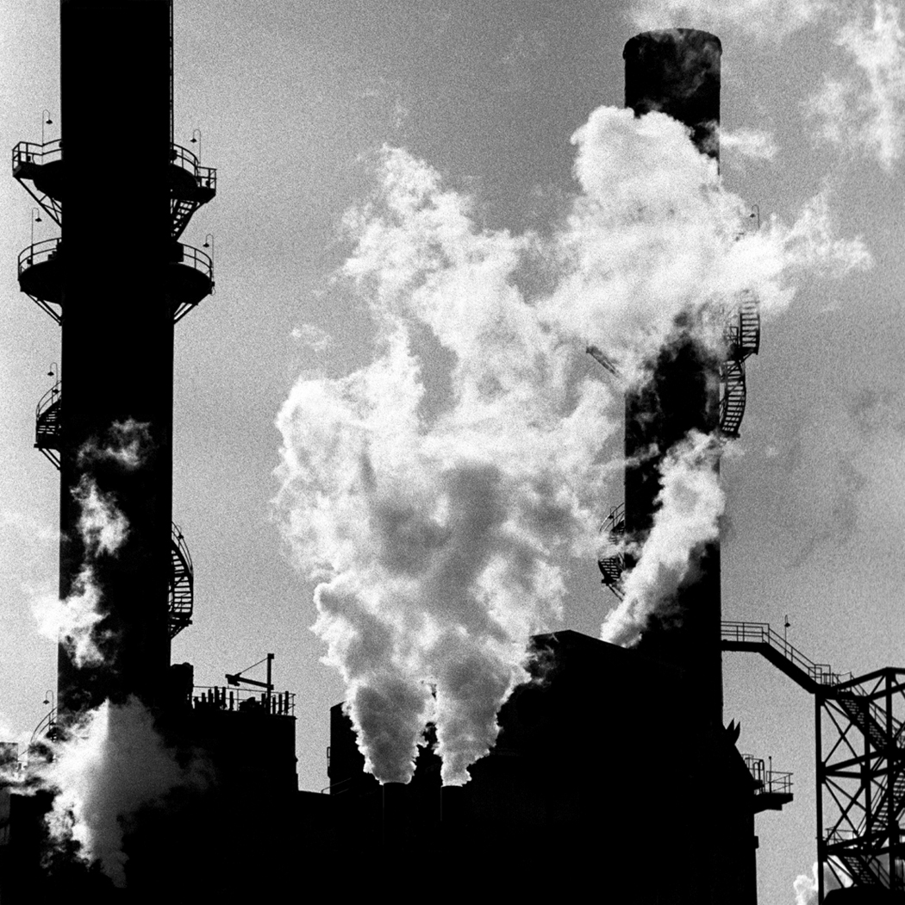Carbon Cycle Drawing Grading Rubric
Name __________________ Class __________
Your drawing or Inspiration concept map includes the following information:

**The ways that carbon enters the atmosphere as carbon dioxide. (And labeled as such)

INCLUDE THE FOLLOWING VOCABULARY AND THE APPROPRIATE PICTURES WITH THEM:

- Fossil fuels-combustion ____ 10
- Factories- combustion _____ 10
- Volcanic eruptions ____ 10
- Decomposers-death ____ 10
- Consumers-respiration ____ 10
- Producers-photosynthesis _____ 10
- You wrote a statement describing four ways that carbon enters the atmosphere as carbon dioxide ____ 40
TOTAL POINTS: ______100 POINTS

- Watch that the arrows are going the correct way.
- Follow your Handout #21 and my poster on the wall about the Carbon Cycle to help you get started.


