**grad%20cylinder.jpg7th Grade Science “I can Statements”microscope.jpg**

**Quarter 1: Unit I**

**Scientific Inquiry Learning Target #1: I can identify questions that can be answered through scientific investigations.** (Scientific Method-Queens Have Expensive Diamond Crystal Crowns) *Step #1 of SM*

**Scientific Inquiry Learning Target #2: I can design and *conduct a scientific investigation.*** *(All Steps of SM)*

**Scientific Inquiry Learning Target #3: I can use appropriate mathematics, tools and techniques to gather data and information.** *(Step #4 of SM)* ***~using correct lab tools safely!***

**Scientific Inquiry Learning Target #4: I can analyze and interpret data from graphs, tables & charts** *(Step #5 of SM)*

**Scientific Inquiry Learning Target #5: I can develop descriptions, models, explanations and predictions**

**Scientific Inquiry Learning Target #6: I can think critically and logically to connect evidence and explanations.** *(Step #6 of SM)*

**Scientific Inquiry Learning Target #7: I can recognize and analyze alternative explanations and predictions** *~Assumption Stories*

**Scientific Inquiry Learning Target #8: I can communicate scientific procedures and explanations.** *(Step #7 of SM)*

**Scientific Inquiry Learning Target #9: I can tell the difference between independent and dependent variables.** (“Dependent Variables Depend on Independent Variable”)

**Scientific Inquiry Learning Target #10: I can explain how variables and controls can affect an investigation.** (Too many independent variables, constants must be the same, etc.)

**\*\*\*\*\*\*\*\*\*\*\*\*\*\*\*\*\*\*\*\*\*\*\*\*\*\*\*\*\*\*\*\*\*\*\*\*\*\*\*\*\*\*\*\*\*\*\*\*\*\*\*\*\*\*\*\*\*\*\*\*\*\*\*\*\*\*\*\*\*\*\*\*\*\*\*\*\*\*\*\*\*\*\*\*\*\*\*\*\*\*\*\***C:\Users\a\AppData\Local\Microsoft\Windows\Temporary Internet Files\Content.IE5\0CFY4UOV\MCj04136360000[1].wmf 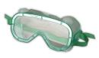 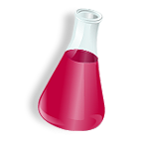 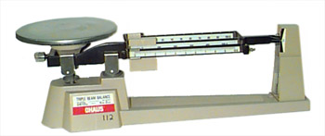 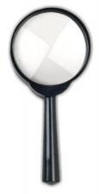

**Shansgen2012**