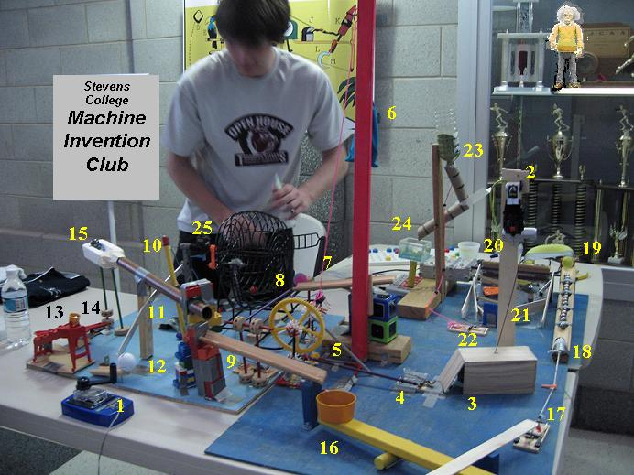
- Use portaportal.com, log in under Guest Access “shansgen”, & find Energy Transformations then “Rube Goldberg”.
- Visit the sites to research the different types of machines that he invented to get ideas for your own.
- You may copy any of the pictures you see; however, you will have to identify at least half of the energies shown in the picture “you borrowed!”
- You may draw, or use Inspiration, PowerPoint or MicroSoft Word to make your project.

GRADING RUBRIC:
Your invention takes at least 6 or 10 steps (Advanced Classes) to do a simple task (like a Rube Goldberg machine) _____25
Your invention has a name ______5
Your invention has all energies correctly identified _____50
Your invention is colorful _____5
You included the “Law of Conservation of Energy” on your project ______5
Your invention has the “Rube Goldberg Project” title, your name, and class color on it _____ 5

TOTAL POINTS _____ 100 pts.
Name _____________________Class color ________ Date turned in _______________

