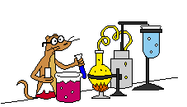Science Lab Tools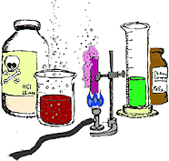
Name ________________ Color Class _________
Match the use with the Science Lab Tool.

- ____Eyewash station A. used to see small objects under larger magnification
- ____Chemical station B. used to measure weight or friction/force
- ____Beaker or graduated cylinder C. used to measure mass in grams
- ____Eye dropper D. used to clean accidental spills from your eyes
- ____Test tube E. used to carry larger amounts of liquids
- ____Magnifying glass F. used to wash accidental chemical spills from body
- ____Triple beam balance G. used to store small amounts of liquid
- ____Spring scale H. used to pick up and disperse small amounts of liquid
- ____Microscope I. portable and used to magnify small objects
- ___Flask J. used to measure volume in mL

Match vocabulary with the definition.
- ____volume A. the amount of mass in a certain volume of matter
- ____mass B. the amount of space an object takes up
- ____density C. a measure of how much matter something contains

